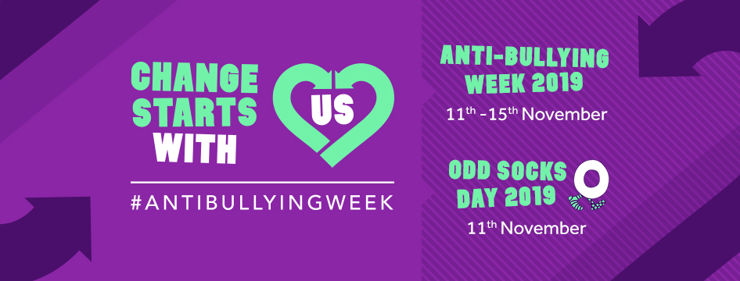
The theme: Change Starts With Us
We have worked with over 1,000 children and young people to decide the theme for this year. The theme aims are as follows:
Small change. Big difference.
Whether it is verbal, physical, online or in-person, bullying has a significant impact on a child’s life well in to adulthood. By making small, simple changes, we can break this cycle and create a safe environment for everyone. Because together, we can challenge bullying. Change starts with a conversation. It starts with checking in. It starts with work together.
Change starts here.
Change starts now.
Change starts with us.
This year the goal is to inform schools and settings, children and young people, parents and carers to know that it takes a collective responsibility to stop bullying. We are excited for this campaign as we want to create empowering, positive messages addressing the fact that when it comes to bullying CHANGE STARTS WITH US!

For more information, go to https://tinyurl.com/y28pfovg

