For E
Badges

If you’d like to enjoy some scouting activities at home, this booklet will give you ideas of badges that can be completed away from the Troop.

Choose the one(s) that interest you most and complete all the requirements listed. There will be various ways to show us you have completed your badge, it could be:
- Sending photos to us or bringing them with you when we next meet
- Worksheets
- Short videos sent to a leader of you demonstrating a new skill

Badges are flexible, and if you can show you have completed badge requirements in your own way that’s great!

Please choose to complete badges that you haven’t already earned with us, as unfortunately we cannot award the same badge twice.

If you have really enjoyed earning one of your activity badges, you can earn an “Activity Plus” badge. To do this we must agree on some requirements together for you to complete. This is available for any of your activity badges, not just the ones in this pack. Please let me know if this is something you’d like to do and we’ll work together to get you going!

If you have any questions about completing a badge, or you’re not sure about something, please contact LEADER NAME, either via email (ADDRESS) or WhatsApp message (MOBILE NUMBER).

Contents

Activity Badges Page(s)

Animal Carer 4

Artist 5

Astronomer 6

Book Reader 7

Chef 8

Collector 9

Communicator 10

Cyclist 11

DIY 12

Entertainer 13

Environmental Conservation 14

Gardener 15

Hobbies 16

Home Help 17

Home Safety 18

Local Knowledge 19

Naturalist 20

Personal Safety 21

Photographer 22

Road Safety 23

Scientist 24 & 25

Sports Enthusiast 26

Animal Carer Activity Badge
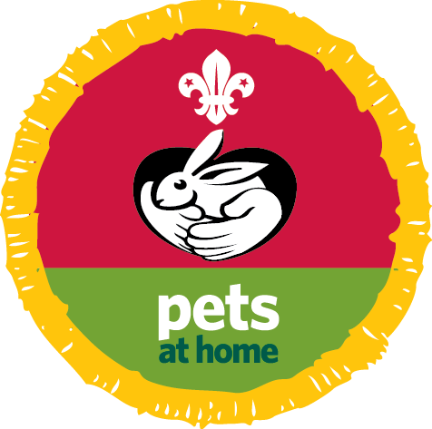
Our partner Pets at Home has produced an activity pack to support the Cubs Animal Carer Activity Badge.
How to earn your badge
1. Complete one of these:
- Take care of an animal for at least two months. Give it the correct foods, and learn to recognise common traits and habits including how to groom, clean and exercise the animal.
- Help to care for a farm animal for at least two months. Know the correct foods to give it and be able to recognise common illnesses. Learn what special care you need to give before and after the birth of farm animals.
2. Then choose two of these to do:
- Keep a record of bird, animal or insect life in your garden, local area or park. Keep pictures, sketches, photographs or audio recordings. Do this for at least three months.
- Visit a zoo, wildlife park, animal sanctuary or rescue centre. Find out about some of the animals you see. What are their feeding habits and natural habitats?
- Join an animal, bird or wildlife society. Either take part in one of its activities or make progress in any award scheme it offers.
- Find out about dangers that threaten wildlife in their natural habitat. Make a poster, collage or drawing or tell other Cub Scouts what you found out.
- Learn and understand what you need to do and be aware of when deciding to own a pet.

Artist Activity Badge
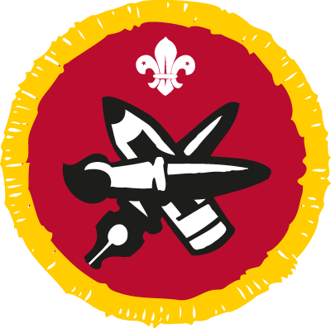
How to earn your badge
Choose three of these activities to do. You must have your leader or another adult with you for one of these activities.
- Imagine an event, character or scene. Now draw it using a pencil, brush, pen or crayon.
- Design and make a greetings card.
- Make a poster advertising Scouting or a Cub Scout event.
- Design and make a decorated book cover.
- Draw or paint a picture of still life or a landscape.
- Make a display of photographs on a subject that interests you.
- Make a video on a subject that interests you.
- Design and build a model.
- Visit an art gallery.
- Make a model out of clay.

Astronomer Activity Badge
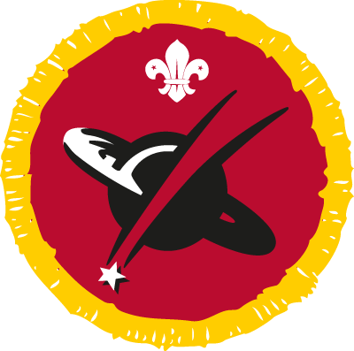
How to earn your badge
- Make a model or draw a simple diagram of the solar system.
- Explain the difference between a planet and a star.
- Learn how to observe the sun safely. Find out and explain how the earth moves around the sun.
- Observe the moon, using binoculars or a telescope if you can. Describe some of its features.
- Identify three constellations.
- Find out about two space-related subjects and present some information about them. You could find out about planets, the history of space exploration or space technology.

Book Reader Activity Badge
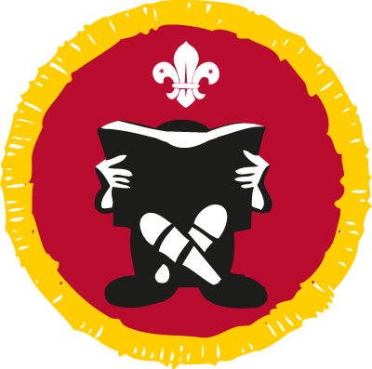
How to earn your badge
- Make a list of at least six books you have read or used recently. Books you have read on an e-reader count too.
- Name the authors of your books. Tell your leader or other Cubs something about three of your books. At least one book should be fiction and one should be non-fiction.
- Show that you know how to care for your books and know the benefits a library can bring to people who enjoy reading.
- Show that you can use a dictionary and a thesaurus.
- Write a review of your favourite book and share it with your Sixer, an Explorer Scout Young Leader or your Cub Leader.

Chef Activity Badge
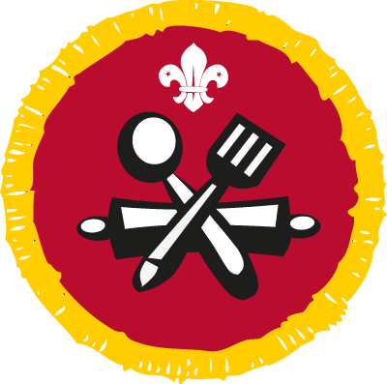
How to earn your badge
- Learn the basic rules of safety and hygiene in the kitchen. Explain why they’re important.
- Talk to your leader about the different ways of preparing and cooking food.
- Learn what the major food groups are. How do they fit into a healthy diet?
- Plan, cook, serve and clear away a two-course meal for at least two people. You should prepare and cook vegetables as part of the menu. Remember, an adult must supervise you for this step. Talk to the people you’re cooking for about the menu.

Collector Activity Badge
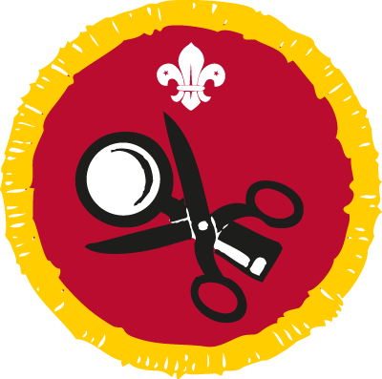
How to earn your badge
- Over three months, build up a collection of similar items.
- Display your collection in an exciting and interesting way. This can include displaying your collection through photographs or using a computer/tablet.
- Talk about items in your collection. Which things particularly interest you?
- View a collection made by someone else. What do you like or dislike about the way it’s presented?

Communicator Activity Badge
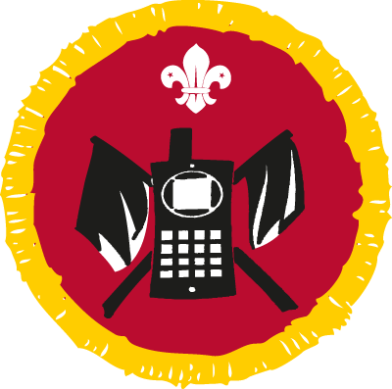
How to earn your badge
- Get someone to give you directions or instructions to do something. Check that you have understood. Then follow the directions or instructions.
- Get someone you know to give you a call. Write down what they say, making sure that you have all the main details.
- Show you can send emails and text messages. You could also show how to use a mobile phone or a tablet to send a message to someone.
- Introduce yourself to an adult who helps out with your Pack. Talk to them for two minutes about your life, school or hobbies.
- Choose three of these activities to do:
  - Report on a local event, either past or present. It could be written
for something like a newsletter or recorded so people can listen to it.
  - Make contact with another Pack. Send them videos, letters or emails for whatever length of time your leader suggests.
  - Find out how people with a visual or hearing impairment communicate. You might learn about Braille, Makaton or British Sign Language. Learn a simple phrase in one of the ways you have learned.
  - Tell a story about an experience you’ve shared with your leaders
and other Cubs. Make sure that you communicate clearly and that everyone is following the story.
  - Hold a simple conversation in another language.
  - Write three simple messages using codes, ciphers, invisible ink or semaphore. Try to work out three similar messages given to you.
  - Get an adult or Young Leader to give you a message. Remember it and repeat it back to them 10 minutes later.
  - Pass a message to someone using amateur radio.
  - Take part in Jamboree On The Air (JOTA) or Jamboree On The Internet (JOTI).

Cyclist Activity Badge
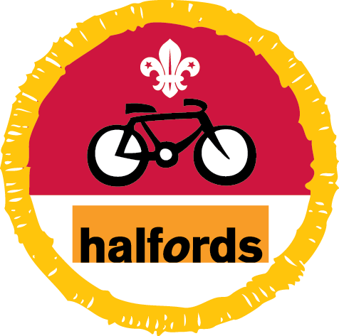
Our partner Halfords has produced activity resources to support the Cubs Cyclist Activity Badge.
How to earn your badge
First, do all five of these tasks.
- Regularly use a bicycle, which is the right size for you, with a cycle helmet.
- Show you can clean and oil a bicycle. Show how to pump up the tyres and mend a puncture.
- Explain why you must lock up a bicycle when you leave it unattended.
- Make a poster to promote road safety to pedestrians or cyclists.
- Talk to your leader or other Cubs about the safety measures you need to take when you cycle in bad weather.
Next, choose one of the two options. Finish all the tasks for the option you choose.
Option 1
- Show that you can mount and dismount your bike properly.
- Show how to keep your bicycle in a roadworthy condition. Why is it important?
- Explain why it’s important to use lights and reflective clothing.
- Go for a short ride in a safe place to show an adult that you can ride safely and confidently.

Option 2
- Find out about the safety equipment you need for cycling off-road.
- Show that you’re able to control your bike over different types of terrain.
- Find out where, in your local area, is safe to cycle off-road.
- Plan and carry out a five-mile cycle ride off-road.

DIY Activity Badge
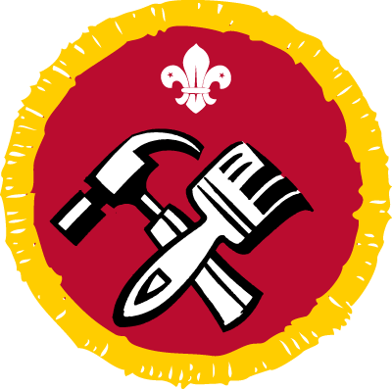
How to earn your badge
- Show how to use and take care of tools safely. Do this for a selection of them, like a hammer, saw, screwdriver, drill or glue gun.
- Talk to your leader about how to work safely on your projects, especially when you’re using electric tools.
- Learn what the difference is between hard wood, soft wood, chipboard, plywood and MDF. For each of them, find out what they’re best used for.
- Help design and make something useful. An adult needs to supervise you. Show that you’re able to:
- measure accurately
- saw
- join pieces of wood together in two different ways
- use a hammer, screwdriver and drill
- prepare surfaces and stain, varnish or paint

Entertainer Activity Badge
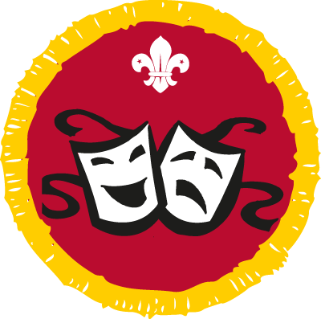
How to earn your badge
Choose two activities from the list to do.
- Help to make up a mime or play, then perform it.
- Perform a puppet play or shadowgraph using puppets that you have made.
- Help to plan and perform some recorded entertainment, like a video or audio story.
- Sing two songs.
- Perform some folk or traditional dances.
- Make a selection of simple rhythm instruments. Use them in a music performance.
- Tell a story to an audience.
- Make up and perform a dance to a piece of music of your choice.
- Help plan and perform a series of magic tricks.
- Take part in a show, concert or band performance.

Environmental Conservation Activity Badge
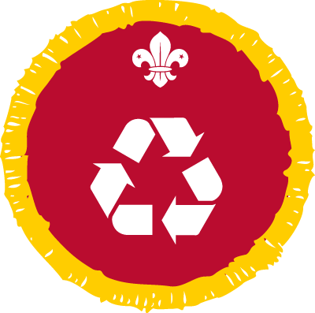
The Cub Environmental Conservation Activity Badge is sponsored by Recycle with Michael. Find out more here.
How to earn your badge
- Learn how to separate recyclable and non-recyclable rubbish ready for
collection. Find out where to take recyclable items that cannot be collected with your normal rubbish.
- Find out how to reduce the energy and water you use in your home. Show how you have encouraged your family to reduce water and energy use over four weeks.
- Find out about one type of renewable energy. Talk to your leader about the advantages and disadvantages of the technology.
- Take part in two projects with a group of other people. You could:
  - clear a ditch, pond or creek
  - make, set up and look after a bird feeder, table, nesting box or bath
  - look after a piece of land or a garden
  - tidy up a piece of wasteland
  - take part in an anti-litter campaign
  - plant a tree or shrub
  - look after a compost bin.

Gardener Activity Badge
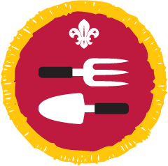
How to earn your badge
- Find out what seasons are best to grow a selection of six fruits and vegetables. Find out what it is about those seasons that make them the right time to grow your fruit and vegetables.
- Learn what tools you need to garden (a minimum of three) and show that you know how to use them safely.
- Help to look after and grow at least one item in a garden or allotment for two months. Alternatively, grow at least two different fruits, vegetables or herbs for two months indoors or in plant pots.
- Design plant labels for the plants you are looking after or growing.
- Understand what mini beasts are and why they are good for our gardens and outdoor spaces. Visit a bug hotel and record what you find living there.

Hobbies Activity Badge
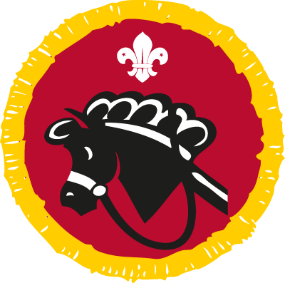
How to earn your badge
- Over three months, be actively involved in a hobby of your choice.
- Show and explain to your leader or Explorer Scout Young Leader what equipment, materials and background information you have used to take part in your hobby including any safety rules.
- Talk about your hobby including why you have chosen it and what you enjoy about it.
- Talk to your leader about how you plan to develop your hobby, interest or skill in the future.

Home Help Activity Badge
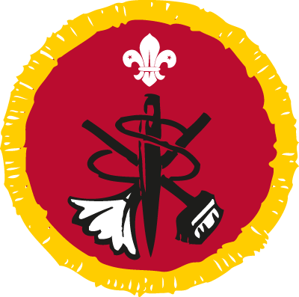
How to earn your badge
- Plan, cook and serve a simple one-course meal.
- Wash up afterwards. Show how to clean a saucepan or other cooking utensils, cutlery and glasses. You could use a dishwasher for this step, including loading and unloading it.
- Help sort out the washing. Load and unload the washing machine.
- Iron at least two items. They could be things like pillowcases, t-shirts or trousers.
- Sew on a button.
- Help to clean and tidy a living room.
- Clean at least two items in your home. They could be things like a basin or kitchen cupboard, silverware or brass.
- Take sheets, pillow covers and the duvet cover off a bed and help to put clean ones on. Make your own bed for a week.

Home Safety Activity Badge
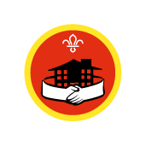
How to earn your badge:
- Find out what to do about a burst water pipe, gas leak or electricity power failure in your home.
- Identify the common causes of accidents in the home. How they can be prevented?
- Find out how to protect your home from crime.
- Find out where the nearest public telephone box is to your house. Where else could you make an emergency call if the public telephone wasn’t working?
- Make a list of useful emergency numbers.

Local Knowledge Activity Badge
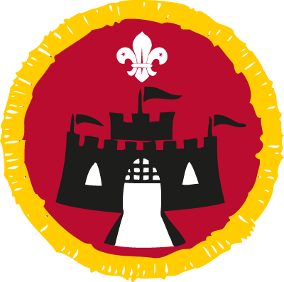
How to earn your badge
Do three of the activities on this list.
- Find out about a famous person who lived in or near your area. The famous person could be from the past or present. Or you could learn about a famous building, monument, earthworks or other place of historical interest and visit it. Talk about what you find out with your leader or other Cubs.
- Collect pictures of your county, borough, district, town or village coat of arms. Find out what the coat of arms represents. Try to find as many different places as you can where the coat of arms is displayed. Tell your leader how many you found.
- Talk to someone who has lived in your local area for a long time. Find out about what life was like when they were young. What changes have they seen in the local area over the years?
- Draw a map of your area. Mark places of interest on it and, with other Cubs, go on a short walk in your local area. Point out any features of interest to your leader.
- Design a poster, leaflet or web page to advertise your area to a visitor.

Naturalist Activity Badge
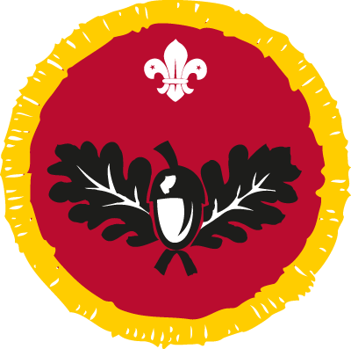
How to earn your badge
1. Learn how to identify six different living things from two of these categories:
- trees
- garden birds
- water birds
- minibeasts and insects
- wild flowers
- pond dwellers
- fungi
- butterflies and moths
That means you should have 12 examples in total.
2. Over three months, visit the same natural area at least four times. Take a note of the changes in the plants and wildlife that you see. You might visit a garden, hedgerow, canal, river lake or park. Make sure that you have an adult’s permission for the visits.
3. Learn the countryside code and how to follow it.
4. Choose one of these activities to do:
- Create a piece of art using natural material. You could do a bark or leaf rubbing, dried flower picture or maybe a collage.
- Use a dye that uses natural ingredients to colour a piece of material.
- Make a feeding station for birds. Get permission to hang it in a good position.
- Make a hedgehog, ladybird or bee house.
- With an adult pick wild edible berries, leaves or fruit. Use them in a recipe.

Personal Safety Activity Badge
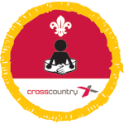
How to earn your badge
- Explain the dangers of playing on or near two of these:
  - railways
  - busy roads
  - building sites
  - cliffs
  - canal banks
  - sand
  - gravel pits
  - farmyards
  - river banks
  - quarries
  - moorlands
  - lakes.
- Show you can use at least one of these codes:
  - Water Safety Code
  - Bathing Code
  - Firework Code.
- Make up a safety code of your own choice. It could be for car passengers, train passengers or the playground.
- Explain what you must do if a stranger starts to talk to you. What must you tell your parents or carers if you are going out without them?
- Find out how and why you might contact a helpline like ChildLine, for example.
- Explain the best ways to stay safe while online. Write down some common sense rules to follow while you are on the internet.
- Memorise your address and your home telephone number
or a parent’s mobile phone number.

Photographer Activity Badge
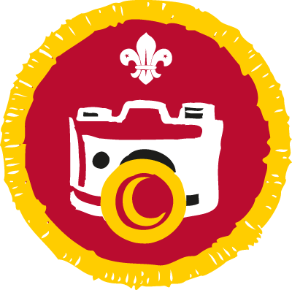
How to earn your badge
- Show that you know how to use and look after a digital camera or smartphone camera. Show how to change the mode, change the settings, use the zoom function, and transfer photos to another device.
- Take at least five photos of your local area that could be used on a tourist leaflet or website.
- Take photos while you’re on a trip, camp or another event. Show 10 of your best photos to someone else after the event. You could present them in a scrapbook, on a screen, in a photo book or some other way.
- Choose one of these activities to do:
- Create two photos of the same thing, one in colour and one in black and white. Compare how the effects change the way the final picture looks.
- Make a short film on a subject of your choice.
- Using a series of photos, make a short animation sequence.
- Edit a photo using a smartphone or editing software. Explain what you have changed and why.

Road Safety Activity Badge
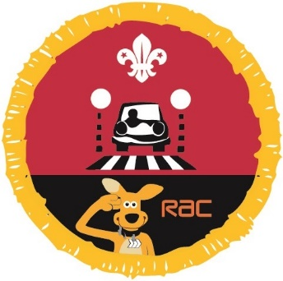
Our partner RAC has produced activity sheets to support the Cub Road Safety Activity Badge.
This is what you need to do to earn your badge.
- Draw or take photos of 10 different traffic signs. Explain what they mean.
- Show how to use the Green Cross Code.
- Tell a leader why it’s important to have different types of pedestrian crossing. Explain how to use them safely.
- Show that you know how to behave safely as a car passenger

Scientist Activity Badge
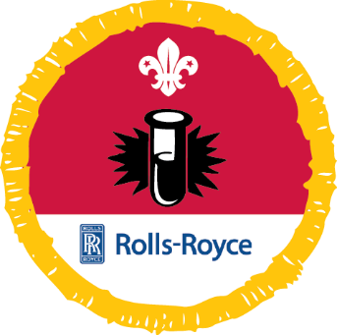
Our partner Rolls Royce has produced activity sheets to support the Cub Scientist Activity Badge.
How to earn your badge
Do six science activities. You should choose two activities from each of these sections.
For each activity, explain or show your leader what you did and what you found out.
Section 1: reactions
- Show how vinegar reacts with different items and explain what happens. The different items could be steel wool, sodium bicarbonate or old dirty coins.
- Find out what happens when you add salt to water.
- Compare the density of water to the density of other liquids. Show how these liquids react to each other.
- Make a pH indicator solution. Use it to test the acidity or alkalinity of other liquids.
- Grow crystals.
- Another activity agreed with your leader

Section 2: interacting with energy
- Create a basic electrical circuit that includes a switch. Show how it could be used to control a lightbulb powered by a battery.
- Make an air-powered balloon rocket or a water rocket. Investigate ways of improving how far it can travel.
- Make a simple compass. Show the effects of metallic and magnetic materials upon it.
- Use marshmallows and spaghetti to build the strongest tower you can. Explain how you improved your design.
- Find a way to show that hot air rises.
- Another activity agreed with your leader

Section 3: living things
- Set up a wormery or ant colony. Record what happens over three or four weeks
- Investigate what happens to your pulse rate before, during and after exercise.
- Grow cress, beans, peas or a similar plant. Investigate what happens when the plant has no access to light. What happens when it has light,
but no water?
- Find a way to show that plants take water up through their stems.
- Make some yoghurt and find out how living organisms are involved in
the process.
- Another activity agreed with your leader

Sports Enthusiast Activity Badge
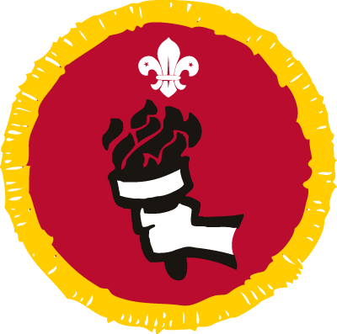
How to earn your badge
- Follow your chosen sport for at least three months.
- Find out the rules of the sport. Explain them to an adult.
- Show you have a good knowledge of the teams and/or personalities in your chosen sport.
- Explain what equipment is needed for the sport.
- List some major events for the sport of your choice.
- Describe events that you have attended for your chosen sport. If you haven’t been to an event, explain to your leader how you keep up-to-date with your sport.

