Cubboree 2018  Kit list for Cubs | 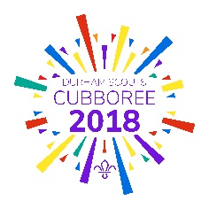

Every great Cub needs to be prepared for a great Adventure – so make sure you’ve got everything you need to have a brilliant weekend.
If you don’t have an item, please ask your leader for advice.

- Full Uniform – please arrive wearing
- Camping Mat
- Sleeping Bag – warm camping type
- Small Pillow
- Nightwear – remember, you’ll be outside
- 2 pairs of Socks
- 2 sets of Underwear
- 2 pairs of Trousers (not Jeans)
- 2 Warm Jumpers / Sweatshirts
- 2 T Shirts
- Warm fleece
- Waterproof Coat
- Waterproof Trousers - if you have some
- Pair of outdoor trainers
- Wellie Boots
- Wash Kit – including toothbrush, toothpaste, soap, brush/comb
- Towel
- Any personal medication – named in a resealable bag
- Torch
- Hat / Gloves
- Sun Hat / Sun cream
- Quiet Game to play with not many small pieces or a book to read – no electronic items
- Plastic Bag to take washing home
- Small water bottle
- Pocket Money

Top tips from the best campers:
- If the forecast is looking like its going to be cold or wet, you may want to pack more.
- Please ensure all kit fits into one large holdall/rucsac type bag which Cubs can carry for 15 minutes.
- Please remember that you’ll be camping and while we hope there will be sun, you’ll need to pack for any weather!
- Please don’t bring any electronic games, iPods, mobile phones, valuables or anything breakable.
- Please ensure everything is clearly labelled with your name and group’s name.
- All items are brought at the owners risk.
Now you’re ready for Cubboree 2018! See you there!

