News from the UK Safer Internet Centre - Impact Report on Safer Internet Day 2020
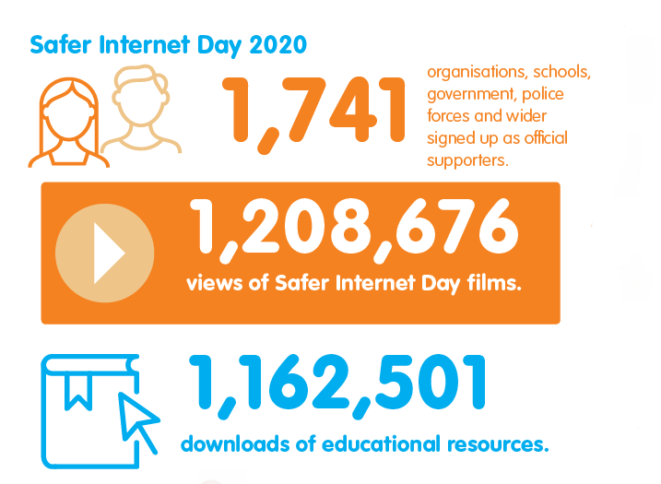

Safer Internet Day 2020 Impact Report published
Safer Internet Day 2020 reached more young people than ever before, with 49% of UK children aged 8-17 hearing about the day. The impact report looks at the reach of Safer Internet Day 2020 and the positive impact that it had on children, young people, parents, carers, and teachers.There was a huge range of Safer Internet Day supporters this year, with 1,741 organisations spreading the word of the day, running activities and joining in on social media. For more information, follow the link:

https://www.saferinternet.org.uk/blog/safer-internet-day-2020-impact-report-published

25th June 2020

