For E
Badges

If you’d like to enjoy some scouting activities at home, this booklet will give you ideas of badges that can be completed away from the Troop.

Choose the one(s) that interest you most and complete all the requirements listed. There will be various ways to show us you have completed your badge, it could be:
- Sending photos to us or bringing them with you when we next meet
- Worksheets
- Short videos sent to a leader of you demonstrating a new skill

Badges are flexible, and if you can show you have completed badge requirements in your own way that’s great!

Please choose to complete badges that you haven’t already earned with us, as unfortunately we cannot award the same badge twice.

If you have really enjoyed earning one of your activity badges, you can earn an “Activity Plus” badge. To do this we must agree on some requirements together for you to complete. This is available for any of your activity badges, not just the ones in this pack. Please let me know if this is something you’d like to do and we’ll work together to get you going!

If you have any questions about completing a badge, or you’re not sure about something, please contact LEADER NAME, either via email (ADDRESS) or WhatsApp message (MOBILE NUMBER).

Contents

Activity Badges Page(s)

Artist 4

Astronautics 5

Astronomer 6

Communicator 7 & 8

Craft 9

Cyclist 10 & 11

DIY 12

Entertainer 13

Environmental Conservation 14

Farming 15

Fire Safety 16

Hobbies 17

Librarian 18

Local Knowledge 19 & 20

Mechanic 21 & 22

Media Relations and Marketing 23

Meteorologist 24

Model Maker 25 & 26

Naturalist 27

Photographer 28 & 29

Scientist 30

Sports Enthusiast 31

Writer 32

Artist Activity Badge
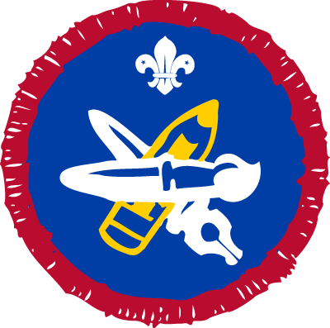
How to earn your badge
Choose from Options 1 or 2. Then complete all tasks under your chosen option.
Option 1: artist
- Paint, draw or illustrate each of these:
  - a scene from a story
  - a person or object
  - a landscape.
- Show a selection of your own recent work.

Option 2: arts enthusiast
- Choose a favourite art form or artist to take an active interest in. It
doesn’t have to be painting – it could be pop music, sculpture, theatre,
architecture, break dancing or anything similar.
- Describe two visits you have made that are connected to your interest. You can use photographs, films, recordings, concert programmes, ticket stubs, newspaper reviews or websites to illustrate your point.
- Show that you know a lot about an aspect of your interest. You could talk about a particular piece of art, like a painting, performance, sculpture or building. Or you could discuss a particular person or historical period connected with your chosen art form.
- Make a list of major events, exhibitions or venues connected with your chosen subject. Talk about why the items on your list are important.

Astronautics Activity Badge
Our partner UK Space Agency has produced activity sheets to support the Scout Astronautics Activity Badge.
How to earn your badge
- Find out how craters are formed, and what meteorites tell us about the universe. You could experiment using marbles, rubber balls or stones as meteorites, and a tray filled with sand as your planet/moon surface.
- Compare satellite images of Mars and the Moon with satellite images of Earth. Point out similar landscape features such as craters, valleys and volcanoes. Discuss what Earth observation can tell us about the land, sea and atmosphere.
- Build your own satellite dish. Discuss what everyday items rely on satellites.
- In a group, debate about life elsewhere in the universe. What might it look like? How do we search for life on other planets and moons? How would the human race react to the discovery of life elsewhere in the universe?
- Find out about the International Space Station and how astronauts live and work on board.
- Research a current space mission, such as a mission to Mars. Then, design a model of your own space probe or other spacecraft, including the instruments on board that enable it to complete its mission.
- Build, launch and recover a model rocket. Think about the shape of your rocket and why that’s important. Make a second launch to achieve a specific objective, such as reaching a certain height or carrying a fragile payload, like an egg.

Astronomer Activity Badge
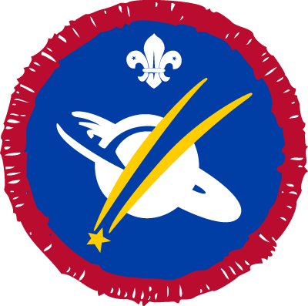
How to earn your badge
- Show what you know about the night sky and why the pattern of stars changes, night by night, throughout the year.
- Learn the meaning of the terms celestial, equator, poles, circumpolar and zodiac.
- Build a model of the solar system using everyday materials found in the home, such as different size fruit or sports balls. Use an outside area to scale the solar system.
- Explain how the Moon affects the tides.
- Build a telescope from two cardboard tubes or two A4 pieces of black card, and lenses. Compare what you can see through a telescope and what you can see with the naked eye.
- Observe three constellations on a clear night and record what you saw.
- Read a star map using a compass and red light. Compare the differences between using a star map and a normal map.
- Learn how to identify a satellite. How do you tell it apart from an aeroplane, star, planet or a meteor? Then complete these activities:
a. identify a satellite to observe
b. choose a clear night and use a clock and a compass to help you
observe the satellite
c. plan an evening with your Scout Group and teach others how to
observe the satellite

Communicator Activity Badge
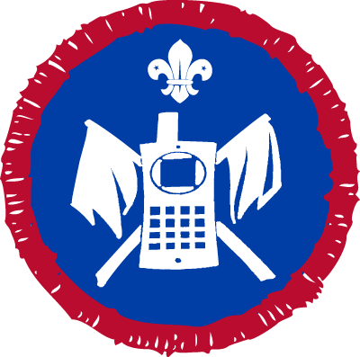
How to earn your badge
Choose from one of the five options. Then complete all the tasks under your chosen option.
Option 1: radio communication
You automatically gain this activity badge if you already hold, or go for, any of these qualifications:
- Radio Amateur Licence (Foundation, Intermediate or Full)
- Marine Radio Operator’s Certificate of Competence and Authority to Operate
- Flight Radio Telephone Operator’s Licence.
If not, complete all of these.
- Log 25 different amateur radio stations. Note the date, time, call sign, frequency, readability and location. You may include some broadcast
stations.
- Show how to tune a simple communications receiver.
- Give an example of a typical greetings message.
- Explain in simple terms how radio waves travel around the world. Learn the more commonly used HF and VHF amateur frequency bands.
- Learn the phonetic alphabet and define at least eight international Q code signals.
- Show that you can recognise call signs from the UK and near continent.
- Visit an amateur radio station.
- Learn the regulations governing the use of amateur radio equipment.

Option 2: communication codes
- Send and receive a short message by Morse code or semaphore at a rate
of five words per minute.
- Show that you know the proper procedure for sending and receiving a message.
- Learn the international phonetic alphabet and define at least eight international Q code signals.
- Construct a simple Morse code oscillator and send a short message.

Option 3: mobile and internet communication
- Show you know how to use your mobile safely and how to keep it safe.
- Learn the meaning of these terms: SMS, MMS, 3G, 4G, WAP and Bluetooth.
- Send a creative text, multimedia or video message to invite a friend to a Scouts event.
- Manage a mobile phone address book and set up groups of contacts.
- Show you can text accurately at a rate of 50 characters per minute.
- Show you know the meaning of some popular chat abbreviations.
- Share photos and videos of a Scouting activity you’ve been involved with, using available technology.
- Manage an email address book and set up groups of contacts.

Option 4: foreign languages
Complete these tasks in any foreign language:
- Carry on a simple conversation for about 10 minutes.
- Write a letter of around 150 words.
- After a few minutes of study, translate a paragraph of basic text.
- Act as an interpreter for a visitor who does not speak your native language.
- Communicate with a person who does not speak your native language.

Option 5: translator
Complete these tasks in a recognised sign language, such as Makaton or BSL:
- Carry out a simple conversation for about 10 minutes.
- Use sign language to describe a Scouting experience to another person.
- Act as a translator for a short conversation between a sign language user and someone with no sign language experience.
- Invite a sign language user to talk to your Troop about what it’s like to have impaired hearing or speech. Help by translating for them during their visit.

Craft Activity Badge
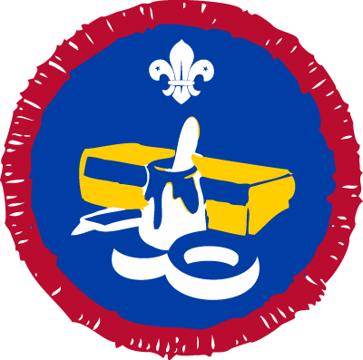
How to earn your badge
To achieve this badge you need to make or decorate one or more articles using, whenever possible, original design ideas.
You should discuss this project beforehand with a member of your leadership team. It should take around six hours to complete the project.
Here are some items you could make:
- A container using basket making, woodturning, pottery, embroidery on plastic canvas, glass blowing or fibreglass construction.
- A belt, bag, wall hanging, tablemat or waistcoat by weaving, macramé, beadwork or from leather.
- An item of clothing or soft furnishing, by sewing or knitting. You may follow a pattern.
- You could decorate clothing or soft furnishing (such
as a cushion or tablecloth) using embroidery, tapestry, lace making, tie and dye, wax and dye or fabric paints.
- A picture, using techniques like mosaic, staining glass, quilting, calligraphy, pyrography, pressed flowers, fabric collage, printing with potato, lino, string, drypoint, aquatint or silkscreen.
- Decorate a material (such as wood, metal or glass) by engraving
or etching. You could even try painting metal with cold enamel.
- Make a decorative item through candle making, arranging flowers, carving (using materials such as wood, slate, stone or soap), fly tying, jewellery making, pewterwork, copper or silversmithing, stone polishing, stone masonry or sculpture.
- Make a small item of furniture.
- Decorate a cake for a special occasion.

Alternatively, you can do any other project of a similar skill level. Just agree it beforehand with your leadership team.

Cyclist Activity Badge
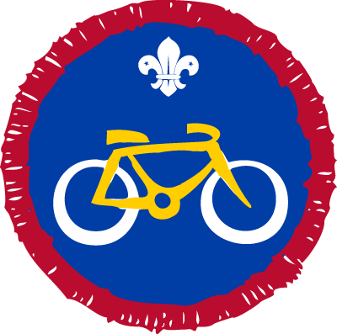
How to earn your badge
There are two parts to achieving this badge. Complete all tasks for part one.
- Use a bicycle that is properly equipped. Keep it in good working order
for at least six months.
- Show that you can carry out essential maintenance and repairs, including:
  - checking and adjusting the brakes
  - checking and adjusting the gear change
  - adjusting the seat and handlebars to a correct height
  - removing a wheel and locating and repairing at puncture
  - checking and adjusting your cycle helmet
  - maintaining a set of lights.
For part two of this activity badge, choose one of these options then complete all the tasks for that option.
Option 1: road cycling
You can automatically complete option 1 if you gain Bikeability Level 2 or 3. Otherwise, here’s what you need to do for this option.
- Explain what extra precautions you should take when cycling in the
dark or in wet weather. Show you understand why motor vehicles take longer to stop in the wet.
- Learn the basics of first aid and what to do if an accident happens.
- Develop a working knowledge of map reading. Orientate a map using a compass or conspicuous features. Estimate distances and times taken to travel.
- Plan and carry out an all-day cycle ride of at least 40 kilometres (25 miles).
- Complete one of these:
  - Show you can control a cycle along a slalom course.
  - Show you understand the Highway Code, including road signs and helmet use.

Option 2: off-road cycling
- Show you understand the Mountain Bike Code of Conduct.
- Show you can control your cycle over different types of terrain.
- Show you’re aware of the damage that may be caused to the environment through careless cycling across the countryside.
- Learn the basics of first aid, including the treatment of hypothermia and find out what to do in the case of an accident.
- Gain a working knowledge of map reading. Orientate a map using a compass or conspicuous features. Estimate distances and times taken to travel.
- Plan and carry out an all-day ride of at least 30 kilometres (20 miles).

Option 3: external qualifications
You can complete option 3 if you reach one of these standards:
- The Gold Trix Award of the British Schools Cycling Association
- Level 3 Go-MTB Award from Cycling Scotland, Sustrans, CTC or Scottish Cycling MBLA.

DIY Activity Badge
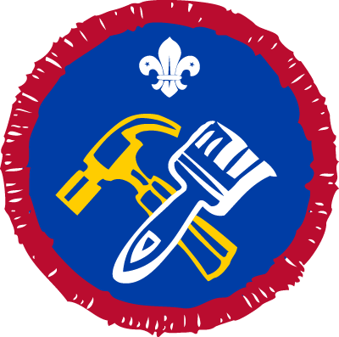
How to earn your badge
1. Show you can work safely and know about the following:
- hazard symbols and signs (for dangers such as toxic, flammable, irritant, electrical danger or slippery surface)
- safety equipment (such as goggles, gloves, masks, ear defenders)
- how and where to turn off mains supplies (such as water, electricity and gas) to the house.
2. Learn how to safely isolate individual electrical circuits at the consumer unit. This includes letting other users know that work is being carried out.
3. Show or explain how you would deal with four DIY emergencies for example:
- unblocking a sink
- patching a leaking pipe
- adjusting the float arm of a cistern
- changing a lightbulb
- hinge a door back in place
- fixing a door bell ringer
- stabilising a wobbly stair rail
- repairing a tear in clothes or upholstery
- removing common stains eg ink, wine, and coffee
4. Take an active part in two major DIY projects, indoors or outside. You could:
- prepare and paint, paper or tile the walls of a room
- prepare and paint woodwork or furniture
- fit a curtain track and hang curtains
- make a freestanding storage unit or put up shelves
- cover a floor with vinyl overlay, lino, tiles or carpet
- hang a door and fit or repair locks and other door furniture
- lay a patio, decking or path
- build a low wall, barbecue, gate or fence
- carry out routine service checks on a car, then clean and polish the car
Alternatively, you could do any other projects of a similar skill level. Agree what you’ll do with an adult who is skilled in the relevant areas.

Entertainer Activity Badge
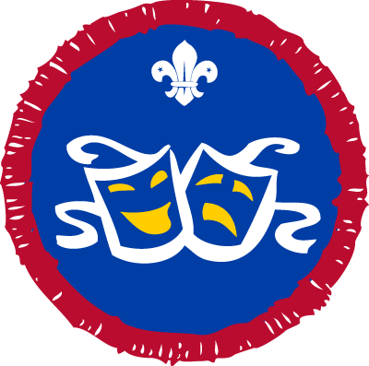
How to earn your badge
Choose one of the options. Then, as part of a group, complete all tasks to achieve this badge.
Option 1
- Write and plan some original entertainment. It could involve a campfire or stage routine involving mime, drama, music, storytelling or conjuring. Alternatively, it could take the form of a presentation featuring sketches, film, slides, tapes, photography or sound recordings.
- Rehearse the entertainment and make sure everyone has a job to do. You might need actors, a producer, a stage manager, front of house or a publicity manager.
- Present the entertainment to an audience at a school, for your Troop or at a parents’ evening.
Option 2
Take an active part in a Scout show or another production. You’ll need to commit to regular rehearsals.

Environmental Conservation Activity Badge
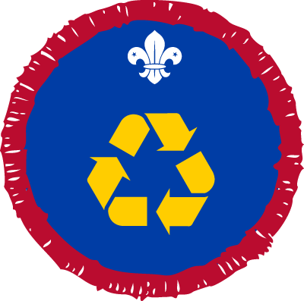
How to earn your badge
- Find out about an environmental issue that is important to your local community. It might be linked to:
  - recycling and conservation
  - energy efficiency in the home or your meeting place
  - the building of new homes and local land use
  - water, light, thermal, air or beach pollution
  - coastal erosion
  - the impact of tourism on the local environment.
- Take part in an activity or project that improves local conservation. It could take place during a weekend conservation camp or you could spread it over at least five weekly sessions. You could look at:
  - recycling
  - reducing energy usage or renewable energy
  - protecting important habitats or wildlife
  - pollution
  - erosion
  - flooding.
- Get involved in a campaign to make others aware of an environmental issue. You could write to your MP and other local agencies or speak to a community group.

Farming Activity Badge
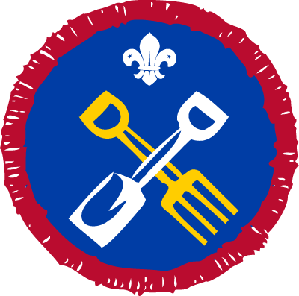
How to earn your badge
Choose one of the three options below. Complete the tasks for your chosen option to achieve this badge.

Option 1
- Learn about farming practices in your area.
- Find out about the organisation, as well as the daily and seasonal operations, of a farm of your choice. Make a note of practices relating to livestock, crops, cultivation, rotation, machinery and labour force.
- Find photos to demonstrate the changes in farming practices that have taken place over a number of years. Explain the reasons for these.

Option 2
- Cultivate an area of garden or an allotment for a specific length of time. Agree this beforehand with your leadership team.
- Show you’re successful in growing:
- three kinds of hardy annual flower
- three kinds of vegetable
- two kinds of bulbs, herbaceous plants, flowering shrubs or rose
- Keep a record of the work you've done and the results you've achieved. This could include height records of the flowers, for example.

Option 3
Keep any kind of livestock for at least three months. You could:
- look after farm animals or birds, and learn how they should be housed, fed and bred as well as their economic uses. Show how to handle them safely and learn about animal welfare.
- manage a hive. Bring in some of the honey you produce.

Fire Safety Activity Badge
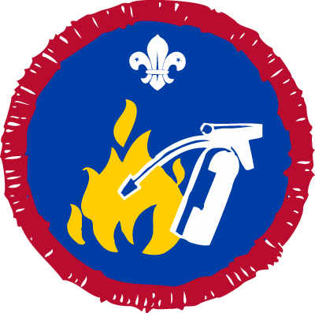
How to earn your badge
- Explain what action should be taken and why, if you discover a fire has broken out in the home or at camp.
- Explain the process of combustion. Find out about the effects of smoke and heat and how to act in smoke.
- Be aware of dangers in the home and the fire precautions necessary for:
  - oil heaters and open solid fuel fires
  - portable electric fires
  - drying clothes
  - electric wiring and fuses
  - smoking paraphernalia, particularly matches
  - uses of household gas, including gas fires
  - party decorations and candles
  - closing doors and windows
  - using BBQs.
- Explain the benefits of installing smoke detectors. Describe the best places to install them.
- Learn what the dangers of campfires are and what precautions should be taken.
- Find out about the causes of heath and grass fires.
- Learn how to make an emergency call for the fire service.
- Identify different fire extinguisher types such as water, dry powder, foam and carbon dioxide. Explain what kinds of fire they should be used on.
- Find out what to do if a person’s clothes are on fire.
- Talk to your family about what to do in the event of a fire at home.

Hobbies Activity Badge
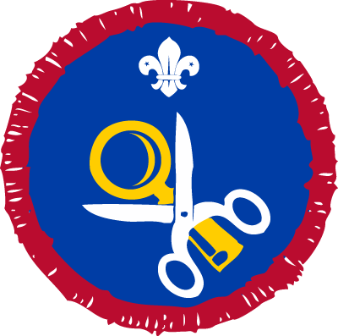
How to earn your badge
Choose one of the two options below. Complete the tasks for your chosen option to achieve this badge.

Option 1
- Take up a hobby or interest that you do not already have an activity badge for.
- Keep a record of your hobby for at least four months.

Option 2
- Make a collection or study of objects for at least four months. You could collect books or magazines, films, cards, key rings, figurines or similar.
- Talk to your Patrol Leader or your Troop about the collection or study you chose. Explain why you chose your objects and what you like about them.

Librarian Activity Badge
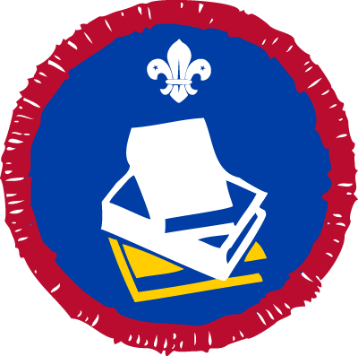
How to earn your badge
- Show that you know how to look after books and e-readers.
- Show that you can use a library catalogue.
- Explain how fiction and non-fiction books are arranged on the shelves. Why are they treated differently?
- Learn what is meant by a reference book or material. Use some of these references to gather information for a journey with a purpose:
  - leisure leaflet or webpage
  - bus or train timetable
  - almanac or a who’s who
- Show how you would search for information using the internet.
- Talk to your assessor about:
  - books you have read and why you enjoyed them
  - information you found from books or websites
  - getting books on the internet for e-readers.

Local Knowledge Activity Badge
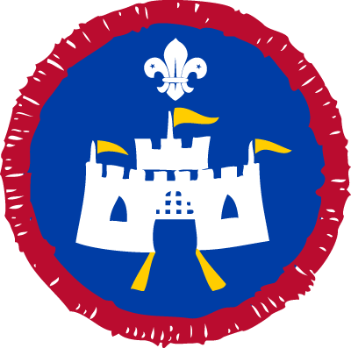
UK Power Networks sponsor the Scout Local Knowledge Activity Badge. They have created useful resources to support you in delivering this badge.
How to earn your badge
Choose one of these three options, depending on where you live. Then complete all the tasks.
Option 1: rural and suburban areas
- Show that you know the local area surrounding your home or Scout
Headquarters, up to a radius of 2 kilometres in suburban districts and 5
kilometres in rural districts. Locate as many as you can of these:
  - doctors, veterinary surgeons, dentists, hospitals and ambulance station
  - fire station, police station, garages, shopping centres, retail parks and convenience stores
  - main bus stops, railway stations and local routes of buses and trains
  - local Scout Headquarters, public parks, theatres, sports and leisure complexes and cinemas
  - places of worship, museums, schools, colleges and local government buildings
  - local routes that take you to the nearest motorway or national routes.
- Use a street map to point out six locations from step 1. From your home or Scout Headquarters, show the quickest route to one of the places.

Option 2: urban areas
- Gain a general knowledge of what parts of the country are served from
your local airport, mainline railway and coach stations.
- Find out how to reach the local airport, mainline railway and coach stations, and major tourist attractions from your Scout Headquarters or home.
- Show how to use a map of your district. Use it to point out any six places of interest. Show how to get to these places from your Scout Headquarters or home.
- Give clear directions to a place of interest 8 kilometres away, to a person travelling by car or public transport.
- Find out which major local roads link to the motorway and A-road network and the main cities these roads serve.
Option 3: heritage
- Study an aspect of national history, local history or family heritage. Exhibit or present the results to other people.
- Over a period agreed with your leader, get involved in a project to help preserve some aspect of national or local heritage.

Mechanic Activity Badge
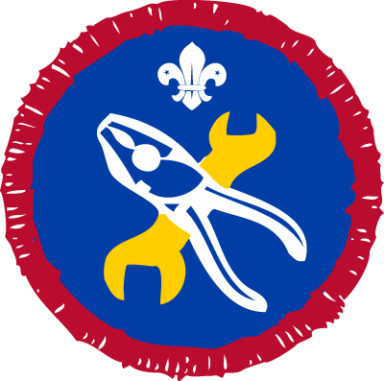
The Scout Mechanic Activity Badge is sponsored by The British Army. You can find their resources here.
How to earn your badge
Choose one of the four options. Then complete all tasks for your chosen option.
Option 1: motor car
- Learn the principles of operating an engine. Make
sure you understand the function of the clutch, gearbox and rear axle
differential.
- Show how to check and refill the windscreen wash bottle of a car.
- Show how to change a bulb at the front and in the rear light cluster of a car.
- Show how to check the level of coolant in the radiator, ‘top up’ the radiator and explain the importance of anti-freeze.
- Show how to check tyre pressures and inflate a tyre correctly.
- Remove and replace a road wheel.
- Explain what to look for when checking that a tyre conforms to the legal requirement. Find out why tyres with different amounts of wear should not be mixed on the same axle.
- Show how to change a wiper blade.
- Explain the outline requirements for an MOT road test.

Option 2: power boat
- Complete one of these activities:
  - Discuss the principles and performance of several types of motorboat engines, other than two-stroke. Show that you know the maintenance needed for a familiar type of marine internal combustion engine, other than two-stroke.
  - Assist with the maintenance, dismantle, service and reassemble an outboard engine. Show how to fit it properly to the transom of a boat. Explain how to detect minor faults in starting and running whilst afloat.
- Complete one of these activities:
  - As driver or mechanic member of a power boat’s crew, help to prepare the boat for a voyage by checking the engine for possible minor faults, checking the fuel supply and pump and mustering the fire-fighting equipment. Show you know how to leave the engine in a proper manner and how to drain the engine in an emergency.
  - Check the engine of a motorboat in preparation for a cruise or expedition, making sure there is fuel that is stored safely, an adequate tool kit and effective fire-fighting apparatus. Accompany the expedition, either as the mechanic or assistant, and be fully or jointly responsible for the operation, care and maintenance of the engine throughout.

Option 3: aircraft
- Learn the basic principles of one these component parts and be able to point them out:
  - an aircraft piston engine
  - an aircraft gas turbine engine.
- Learn the basic principles of flight and airframe construction of a fixed wing aircraft.
- Learn and then demonstrate Aircraft Marshalling signals used by day and night.
- Show you can carry out any four of these:
  - replenishing a light aircraft fuel and oil system safely
  - rigging and de-rigging a glider
  - picketing a light aircraft
  - changing plugs on a light aircraft engine
  - inspecting aircraft main and tail or nose wheel tyres for serviceability
  - repairing a small tear in the fabric surface of a light aircraft or glider
  - checking the control system of a light aircraft or glider for correct sense of movement.

Option 4: motorcycle or scooter
- Learn the principles of operating an engine. Learn about the function of the clutch, gearbox, carburettor and transmission of a motorcycle.
- Check and top up the level of the engine oil.
- Explain how to adjust the tension of the final drive chain.
- Show how you change a bulb at the front and in the rear light cluster.
- Show how you would check tyre pressures and inflate a tyre correctly.
- Remove and replace a road wheel.
- Explain what to look for when checking that a tyre conforms to the legal requirement.
- Explain the outline requirements for an MOT road test.

Media Relations and Marketing Activity Badge
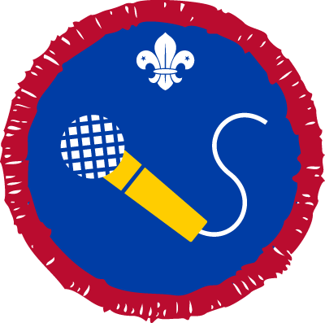
How to earn your badge
Choose from three of these activities to achieve this badge.
- Produce and give a presentation about Scouting. Use audio and visual media and think about how you can make it relevant to people not involved in Scouting.
- Write a press release about a Scout event that has taken place. Send it to your local Media Development Manager so that they can get it published in the local press, radio station or community website.
- Find out about local media outlets such as radio, TV, newspapers and online. Find out what their target audience is and work out a storyline that they might be interested in featuring.
- Prepare and present an audio or video package about a Scouting event or activity. The report should be accurate, informative and reflect the adventure of Scouting.
- Prepare a creative display about your Troop or Group that can be exhibited in your local library, information centre or public place.
- Interview a local public figure or someone in the local news, such as a church leader, politician or celebrity and present the interview to your Troop. Get some advice from your Leader before contacting the person.
- Produce some media which can be used within Scouting, such as a district newsletter story or a piece of website content.

Meteorologist Activity Badge
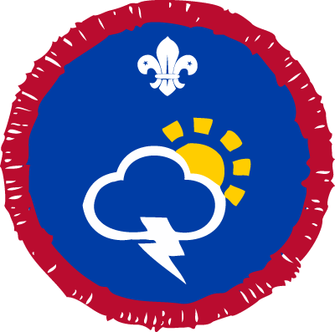
How to earn your badge
- Explain how each of these are measured:
- wind force and direction
- cloud type and extent
- temperature
- pressure
- rainfall
- humidity
- Record the weather conditions every day for two weeks, or once a week for three months. Use equipment like a rain gauge or an outdoor thermometer.
- Identify different cloud types. Describe how they are formed.
- What do ‘warm’ and ‘cold’ air masses in summer and winter do to the typical weather in your area? Describe the effects on land and sea.
- Explain how weather forecasts are created.
- Show that you understand a synoptic weather map, including fronts and isobars. Explain how the measurements in step 1 relate to the map.

Model Maker Activity Badge
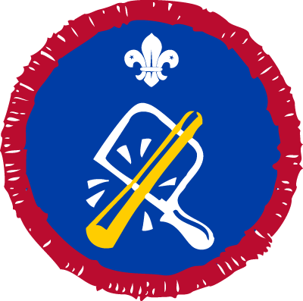
Warhammer sponsor the Scout Model Maker Activity Badge to provide young people with new and creative ways to learn skills for life. To find out more about this partnership and to apply for a free resource pack please click here.
How to earn your badge
Choose one of these five options. Then complete all steps for your chosen option.
Option 1
- Choose one of these activities:
  - Build a model using a plastic or white metal kit or pre-cast figures.
  - Design and construct a model from a wood, plastic or metal construction set, such as Lego or Meccano.
- Show that you know the different types of kits or parts available in the material you chose.
- Talk about the experience of building the model with a knowledgeable adult.
Option 2
- Build a model aeroplane, using a kit if you want to. It must meet one of these target flight performances:
  - A hand-launched glider must fly for 25 seconds.
  - A tow-launched glider must fly for 45 seconds, with 50 metres maximum line length.
  - A rubber-powered aircraft must fly for 30 seconds.
  - An engine-powered aircraft must fly for 45 seconds, with 15 seconds maximum motor run.
  - A control line aircraft must show a smooth take-off and landing, with three laps of level flight at about 2 metres, with a climb and dive.
- Talk about the experience of building and flying the model with a knowledgeable adult.

Option 3
- Build an electric or engine-powered model boat or yacht at least 45 cm in length. Show that it’s capable of maintaining a straight course of at least 25 metres. You can use a kit if you like.
- Talk about the experience of building the model with a knowledgeable adult.

Option 4
- Choose one of these two activities:
  - Build an electric slot car racer. Drive it a minimum distance of 122 metres on any track, without stopping or leaving the slot more than four times.
  - Build a free running car of any type. Show that it can run for at least 18 metres. Airscrew drive is allowed and you can use a kit if you like.
- Talk about the experience of building the model with a knowledgeable adult.
Option 5
- Build a model coach or wagon. Show that it can run properly behind a scale locomotive.
- Build a scaled scenic model, such as a station or farmhouse for a railway layout. You can use a kit if you like.
- Talk about the experience of building your models with a knowledgeable adult.

Naturalist Activity Badge
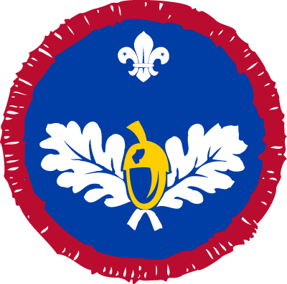
How to earn your badge
- With appropriate permission, spend at least one day at one of these locations and investigate the wildlife and plants found there:
  - woodland or parkland
  - down land
  - moor land
  - seashore or sand dune
  - hedgerow
  - roadside verge
  - stream, river or canal
  - small pond
  - wetland or marshland.
- Tell a knowledgeable adult what you discovered. Show them your field notes, sketches, photographs or maps.
- Find out more about a plant, animal or particular wildlife from your chosen location.
- Discuss what you found out, giving sources for information from places like museums, field guides or the internet.
- Discuss how human activities or land management can affect wildlife.

Photographer Activity Badge
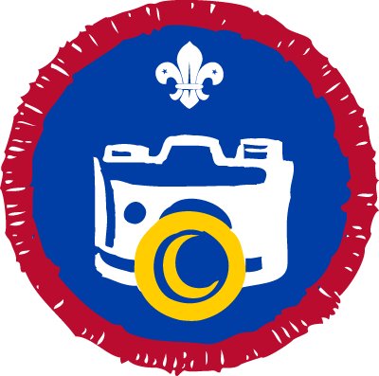
How to earn your badge
Choose one of these two options. Then complete all tasks for your chosen option.
Option 1: still photography
1. Choose one of these two activities:
- Produce 12 photographs, featuring at least two of these photographic techniques: portrait, still life (or similar), landscape or seascape, sport or action, or timelapse.
- Produce six black and white photographs, based on a theme of your choice. Explain the steps you took to create them and the impact of using black and white as an alternative to colour images. You could produce high quality prints on photographic paper or present them on screen.
2. Show that you know the main settings on a digital camera or a smartphone camera. This should include focus and exposure control, and flash settings. Explain the impact of shutter speed and aperture size on the image.
3. Describe what accessories are available to use with digital cameras or smartphone cameras.
4. Edit a selection of your images, using editing software on a computer or using an app on a smartphone. This could include cropping, colour, contrast or light levels. Explain what you have changed and how it improved your image.
5. Diagnose typical faults that happen at the photographing or editing stages, such as over or under exposure and high or low contrast. Explain how to reduce camera shake and how to respond to subject movement.
6. Show that you know how to care for a digital camera or smartphone camera.
Option 2: video photography
1. Produce at least two short films from two of these categories.
- documentary
- music video
- drama
- comedy
- advertisement
- training film
Create a storyboard and script for each of these. Edit the film using editing software on a computer or a smartphone app.
2. Show that you understand:
- camera techniques such as panning, zooming, close-ups, long shots and using additional lighting.
- production techniques such as editing, how to avoid jump cuts and maintaining continuity.
3. Choose one of these two activities:
- Show that you know how to care for a video camera and accessories, such as storage media, batteries, microphones and lights.
- Discuss the differences between recording video on a video camera, digital camera and a smartphone.

Scientist Activity Badge
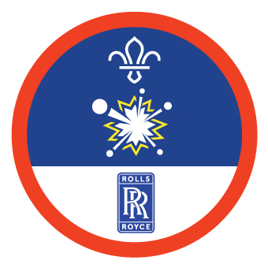
How to earn your badge

Choose from options 1 or 2, then complete all of the tasks under your chosen option.

Option 1

1. Explore and discuss the science behind two Scouting activities or hobbies. For example, you could investigate the science behind a perfect campfire, how a kayak stays afloat and travels through the water, or how a compass or GPS device works.

2. Complete one of these:
- Plan and complete your own experiment to explore the science behind one Scouting activity or hobby. Record your findings and explain what these mean to others. Try thinking of a question you want to answer or something you want to prove.
- Plan and run an activity, demonstration or presentation to help others understand the science behind a Scouting activity or hobby.

Option 2

1. Plan and complete three science experiments or activities. You could try making invisible ink, creating an eruption, designing a catapult or putting together a battery. Check your plan with an adult first, then for each experiment:
- Change something about the experiment or activity and try it again, at least once. Predict what you think will happen and find out if you were right.
- Show that you understand the science behind your experiment or activity.

2. Find out how one of your experiments or activities links to the real world. Then, explain it to others. For example, if you made a battery, what are batteries usually made from? If you created an eruption, how similar or different is this to how volcanoes erupt?

Sports Enthusiast Activity Badge
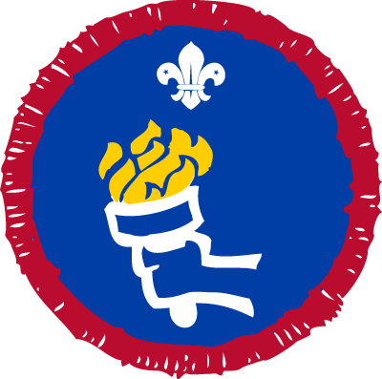
How to earn your badge
- Explain the rules governing your favourite sport.
- Describe the levels of achievement within your chosen sport locally, nationally or internationally.
- Show that you know some of the personalities, champions or other experts in your chosen sport. Explain how they might have inspired you.
- Talk about the equipment needed for the sport.
- Describe a recent major event, championship or landmark in the sport.
- Explain how you follow your sport. How do you keep up to date with developments?

Writer Activity Badge
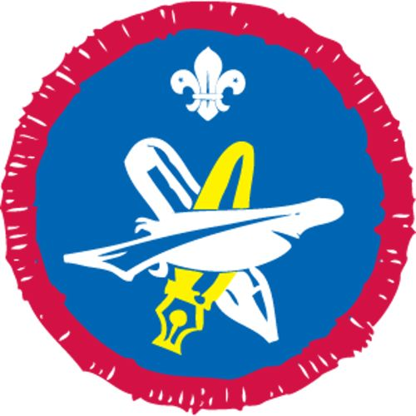
How to earn your badge
Complete four of these activities. Talk about your choice with an appropriate adult.
- Compose a poem of at least eight lines. Discuss its meaning and construction.
- Create a short story of around 600 words. Talk about your story idea with an appropriate adult beforehand.
- Write a descriptive passage of around 600 words on a subject, agreed with an appropriate adult beforehand.
- Write a 600-word review of a favourite book, play or other work of literature and talk about it with an appropriate adult.
- Produce a published article of around 600 words in length. You could contribute to a school, faith, community or Scout magazine or write a letter to a local paper.
- Keep a diary on a subject, for a length of time agreed with an appropriate adult beforehand.
- Write a play or dramatic sketch lasting at least 10 minutes.
- Interview a local celebrity, or other notable person. Write or type out the interview to show the questions you asked and the interviewee’s replies.
- Write a letter to a pen pal (real or imaginary) of at least 600 words.

